Business Service Level Description

**PREDICTIVE PURCHASE RSP**

**Version History**

| **Version** | **Date** | **Change** | **Responsible** |
| --- | --- | --- | --- |
|  |  |  |  |
|  |  |  |  |
|  |  |  |  |

This agreement is between **IT (represented by Regional IT) and the Business.**

E2E/IT Service Name :

Service Description :

**Signatories:**

E2E Service Owner :

IT Service Owner :

Service Quality Management : Therina Foley

Director Global IT Serv. Mgmt. : Biswajit Ghosh

Start Date :

Review Date :

**BSLD Document Naming Convention:**

BSLD_Region/Country abbreviation_NameofService_Version Number_dd.mm.yyyy (date of last review)

Table of Contents

1. Description of Service 4

1.1. Business Purpose of the Service 4

1.2. High Level description of the Criticality and Business Impact of Service 4

2. System Architecture 7

2.1. Interfaces 7

2.2. Geographic Variations in Business Process or Service 8

3. Key Customers of the Service 8

3.1. Key Users /Customers 8

3.2. Information Technology and Business Responsibilities 9

4. Service Level Measurements 9

4.1. Availability 9

Availability 9

Agreed Operating Hours 10

4.2. Resolution Timeframes 11

5. IS Continuity and Backup Strategy 12

5.1. Back up, Restore and Recovery Point Objective (RPO) 12

5.2. IS Continuity Strategy & Recovery Time Objective (RTO) 12

5.3. Business Continuity 14

6. Service & Maintenance Windows 14

6.1. Technical Change Management 15

**Business Service Level Description**

# Description of Service

## Business Purpose of the Service

*The purpose of this Service is to provide functionality that adds value to customers in packaged gas market. In this highly competitive environment, it is critical to acknowledge the value add and limit churn. This can be achieved through a product portfolio that allows for value add into the customer, driving growth and complementing their business.*

*Currently, the sales teams or individuals are responsible for providing value add to customers based on their knowledge of the business and portfolio of products. However, this approach lacks consistency and the messaging is unable to be measured. Therefore, this Service aims to provide a consistent and measurable approach to value add for customers.*

## High Level description of the Criticality and Business Impact of Service

*State the importance of the functionality of this Service to the business and complete the check boxes below to detail the impact.*

Indicate the relative impact of the loss of this application on the Business Process for each of the time periods below. Assume the outage is continuous and occurs during a time of peak business activity.

* Catastrophic - Out of business and/or endanger public safety
* Significant - Major impact on the long-term financial status of the Company and/or endanger public safety.
* Moderate - Major impact of the short-term financial status of the Company.
* Minor - No impact to the financial status of the Company.

Select just one choice per row

|  |  |  |  |  |  |  |  |  |
| --- | --- | --- | --- | --- | --- | --- | --- | --- |
| 1 Hr. |  | Minor |  | Moderate |  | Significant |  | Catastrophic |
| 8 Hr. |  | Minor |  | Moderate |  | Significant |  | Catastrophic |
| 48 Hr. |  | Minor |  | Moderate |  | Significant |  | Catastrophic |
| 72 Hr. |  | Minor |  | Moderate |  | Significant |  | Catastrophic |
| 1 Week |  | Minor |  | Moderate |  | Significant |  | Catastrophic |
| 1 Month |  | Minor |  | Moderate |  | Significant |  | Catastrophic |

Comments

Click here to enter text.

Indicate important timing considerations by selecting critical days of the week, months of the year or other considerable time frames.

|  |  |  |  |  |  |
| --- | --- | --- | --- | --- | --- |
| Days of the Week | | Months of the Year | | Other | |
| All Days |  | All Months |  | All time periods below |  |
| Monday |  | January |  | End of Month |  |
| Tuesday |  | February |  | End of quarter |  |
| Wednesday |  | March |  | End of year |  |
| Thursday |  | April |  | End of fiscal year |  |
| Friday |  | May |  | End of calendar year |  |
| Saturday |  | June |  |  |  |
| Sunday |  | July |  |  |  |
|  |  | August |  |  |  |
|  |  | September |  |  |  |
|  |  | October |  |  |  |
|  |  | November |  |  |  |
|  |  | December |  |  |  |
|  |  |  |  |  |  |

Quantitative Impact and loss estimation: For items listed below select the appropriate level

Select just one choice per row

|  |  |  |  |  |  |  |  |  |
| --- | --- | --- | --- | --- | --- | --- | --- | --- |
| Reduced Productivity |  | Minor |  | Moderate |  | Significant |  | Catastrophic |
| Increased Expenses |  | Minor |  | Moderate |  | Significant |  | Catastrophic |
| Delayed Collection of Funds |  | Minor |  | Moderate |  | Significant |  | Catastrophic |
| Reduced Income/Revenues |  | Minor |  | Moderate |  | Significant |  | Catastrophic |
| Lateness Penalties |  | Minor |  | Moderate |  | Significant |  | Catastrophic |
| Compliance Penalties |  | Minor |  | Moderate |  | Significant |  | Catastrophic |

Others (Please define)

Click here to enter text.

Please give your best estimate. Define losses if this/these Business Processes could not be provided and the time frame associated with the selected loss amount.

|  |  |  |  |  |  |
| --- | --- | --- | --- | --- | --- |
| First Select Just One Amount | | Then Select the time period associated with the amount | | | |
|  | Less than $1,000 |  | Per Hour |  | Per Day |
|  | Between $1,000 to $9,000 |  | Per Month |  | Per Year |
|  | Between $10,000 to $99,000 |  |  |  |  |
|  | Between $100,000 to $499,999 |  |  |  |  |
|  | Between $500,000 to $999,999 |  |  |  |  |
|  | $1,000,000 or more |  |  |  |  |

Comments

Click here to enter text.

# System Architecture

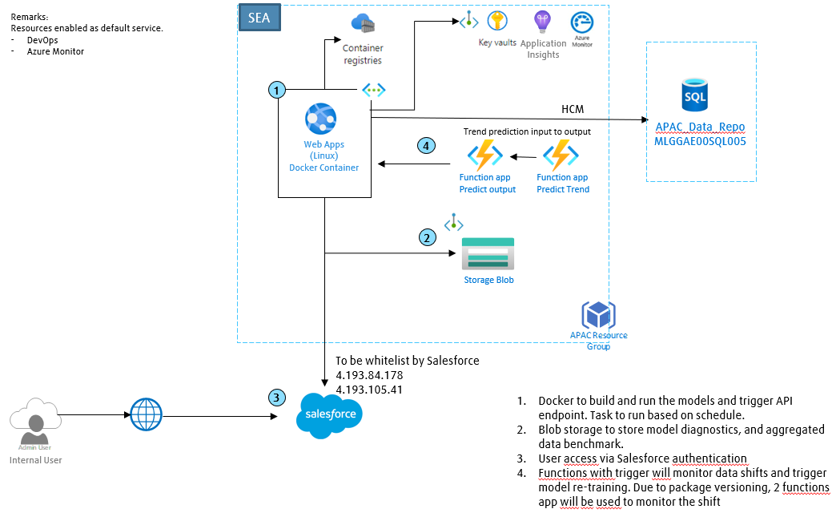

Detail dependencies, interfaces, inputs, etc. should be documented within the CMDB

**Dependencies**

Dependencies on and Interfaces with other Applications

Interface with salesforce via API

Major Output Feeds into other systems

Feed into salesforce

## Interfaces

*Please describe the interfaces to other systems and their purpose, refer to the schematic or CMDB as you see fit. Also Describe how the users would interact with the system (Interact directly with the system, integrated through feeds via a different system or intermediary system).*

## Geographic Variations in Business Process or Service

*Relates to services delivered to multiple geographies/Regions where the delivery of the service may differ across those geographies/regions, for example regional components may be outsourced in one region but in-sourced in another. This section is not applicable for all services and may be removed if not required.*

# Key Customers of the Service

## Key Users /Customers

*Sales Rep: Identify churn risk, opportunities, and action plan*

## Information Technology and Business Responsibilities

*Using the table below create a RACI of the key responsibilities between the business and IT whether corporate IT or regional/country IT. Consider items such as user education, first line support, master data maintenance, user administration, etc.*

|  |  |  | ***RESPONSIBILITY*** | | | | | |  | |
| --- | --- | --- | --- | --- | --- | --- | --- | --- | --- | --- |
| **Task Ref** | **Task Category** | **Task** | **IT Service Owner** | **Corporate IT** | **Regional IT Team** | **Regional Business Team** | **3rd Party vendor** | **Additional Comments** | |
| 1 | Application Data | Master data maintenance,  user administration |  |  |  | A, R |  |  | |
| 2 | Application development & operation | Application support, integration, release management, testing, deployment, performance monitoring | A | C | R |  |  |  | |
| 3 | Application security | Fix vulnerability, ensure application compatible with supported runtime environment | A | C | R |  |  |  | |
| 4 | Azure Hosting | Resources Mgmt- creation/deletion/modification-Scale up/ down/ alerts/ RG access Mgmt  Cost management, Backup  Security setup and monitoring. | A | C | R |  |  |  | |
| 5 | Baseline  Governance | Security, Setup, Management, Compliance, Cost. Etc.. |  | A, R | R |  |  |  | |
| 6 | Network | Design, Security, Connectivity |  | A, R | I |  |  |  | |
| 7 | Platform Base service | Provide hosting platform base service and operations.  Virtualization/Servers/Networking |  | A |  |  | R |  | |

# Service Level Measurements

## Availability

## Availability

*Please state the target Service Level for the Availability of the E2E/IT Service(s) covered by this BSLD.*

*The availability of the Service can be result of the availability of a number of IT services. These IT Services are themselves made up of infrastructure and application components. For example, Technology or Application IT Services combined with Network Services (LAN, WAN), Workplace (Desktops, Laptops, Handhelds)*

*Deriving these targets is a result of consideration of underpinning contracts with Providers and/or OLAs.*

*Standard formulae are used:*

*Serial*

*A = Ax Ay*

*Parallel*

*A = 1-(1-Ax) 2*

For IT Service hosted centrally at TSI the Service offered will be one of three bands delete as appropriate

## Agreed Operating Hours

In normal circumstances the service will remain available. Global Change management process will be followed for planned/emergency downtime

**Agreed Service Hours, Incident and Escalation Process**

The service needs to be available during RSP office hour.

Support will be available during normal working hours of Singapore (9 AM – 6 PM) and target resolution time will be based on incident priority.

In the event that tickets are raised on a non-working day, they will be handled by the support team on the next working day.

For high priority ticket, incident management process will be followed.

**Incident Handling Process per Country / Region (Example (**[**template available here**](https://lindegroup.sharepoint.com/sites/Global_Delivery_Services/serviceleveldescription/ISManagementOfficeServiceLevelDescriptio/SitePages/HomePage.aspx)**)**

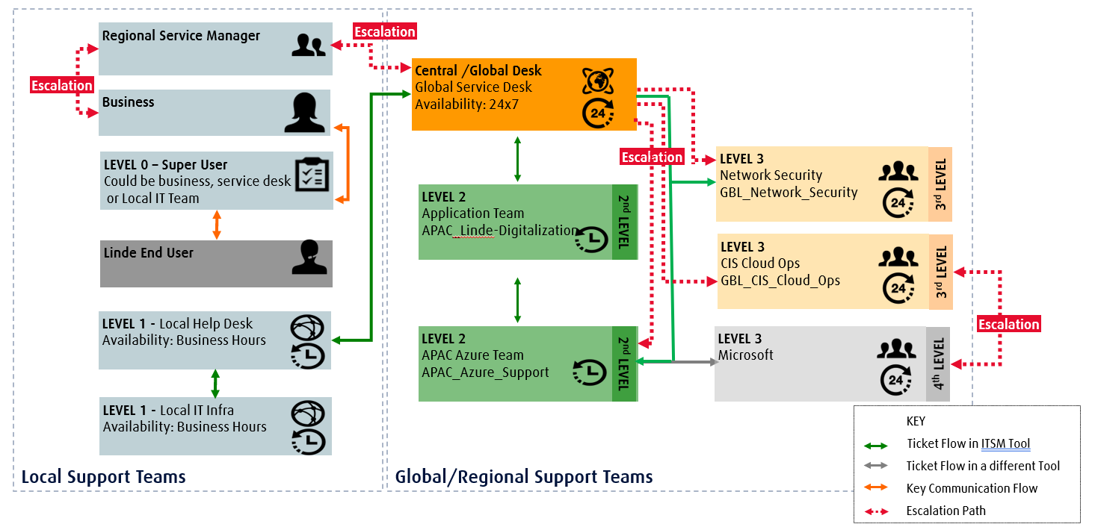

## Resolution Timeframes

Follow Global Incident Management Process. Incident target fixed time based on Incident Priority.

# IS Continuity and Backup Strategy

## Back up, Restore and Recovery Point Objective (RPO)

**Recovery Point Objective (RPO):** Recovery Point is the point prior to the disaster up to which data recovery can be accomplished given current architecture and backup arrangements

Describe the Backup arrangements for the applications

Application – Hourly, 30days retention

Database – Daily backup, 30days retention, Transaction Log backup every 2 hours

Based on current architecture, expected RPO of this application

24 hours

Outline business coping strategies to ensure recovery of and completeness of data i.e. recovery from other sources, manual data entry, etc. if RPO is not till the point of disaster

Recovery will be trigger with script with T-1 month

## IS Continuity Strategy & Recovery Time Objective (RTO)

**Recovery Time Objective (RTO):** Based on the above criteria, document the agreed RTO for this Service.

Recovery Time Objective is defined as the period between an unplanned interruption of business operations and the resumption of business. Note: This is just to capture the objective based on the criteria. Actual recovery arrangements are detailed in the Recovery section.

Please check one only. If RTO is less than one day, please specify the number of hours in the comments field.

Less than 1 day

Up to 2 days

Up to 4 days

Up to 2 weeks

Up to 1 month

Up to 3 months

Comments:

Click here to enter text.

**Recovery Time Performance Aspects:** Describe if you can continue business operations or scale down but still continue operations if the application is recovered but might be running in a degraded mode i.e. if the application is running slower, response times are lower than normal.

Yes, recovery time is not time sensitive

**Service Recovery Plan:** Document requirements and plan for recovery of the application- recovery script etc

Web apps service: Supported by Microsoft Disaster Recovery mode strategy.

Database: Restore from backup

**Testing strategy, frequency, and additional comments:** (Also list test scripts etc)

Click here to enter text.

## Business Continuity

Use this section to describe how the business process will be supported until the RTO or recovery plan is executed in the event of a disaster. Also, while the IT recovery plans are expected to provide recovery, please also document any alternate recovery strategies that could be used in the unlikely event of delays in recovery due to any extreme / unforeseen issues:

Describe any documented manual procedures that could be used without IT support. These would be business continuity or contingency plans that are in place. Please describe or enter links to such procedures.

Recovery will be trigger with script with T-1 month

Provide the date when the manual procedures were last tested or used. Enter comments describing the outcome

17/05/2024

List additional IT Support Requirements (Helper Text: Help Desk, Network Technicians, Security)

Click here to enter text.

Percent of production which could be supported when utilizing the alternate processing mode

Click here to enter text.

Maximum amount of time which this alternate process could be performed

Click here to enter text.

# Service & Maintenance Windows

The service needs to be available during business hours from Monday to Friday. Maintenance will be performed in the weekends or after office hour.

## Technical Change Management

Follow Global Change Management Process for technical change management. HP-SM tool is used to manage change management. The change approver generated automatically in Change Request based on CMDB.